A First Project Final Report On

**Food Ordering System in Restaurant**

Submitted in Partial Fulfillment of the Requirements for the Degree of

**Software Engineering**

Under Pokhara University

Submitted by:

**Name:** Rojan Karki **Roll No:** 171629

**Name:** Prakash Bhandari **Roll No:** 171625

Under the Supervision Of

**Mr. Roshan Chitrakar**

*PhD (Information Security)*

*Associate Professor, NCIT*

Date:

2nd January 2020



**Department of Software Engineering**

**NEPAL COLLEGE OF**

**INFORMATION TECHNOLOGY**

Balkumari, Lalitpur, Nepal

# 

# Acknowledgement

We acknowledge our gratitude towards our project supervisor Mr. Roshan Chitrakar for his guidance and encouragement throughout the project duration. We would also like to offer deep gratitude to college administration and our department for providing us this opportunity. We would like to express our great appreciation to everyone else who helped us in this project directly and indirectly, without whom this project would not be a success. We are very grateful that combined efforts from us and all our teachers has helped us to complete this project within the timeframe.

# Abstract

The food ordering system is a web based application designed to help customer in ordering foods in restaurant. This system uses Php for backend and HTML,CSS ,JS and JQuery for front end design. It also uses Ajax which makes it faster and more interactive. MySQL database is used to store data.

The customer sends order via intranet of restaurant and the kitchen receive that order and serve the customer. This application is hosted on locally hosted server. This whole process is based on Transmission Control Protocol and uses GUI technology for click and order.

Keywords: Php, HTML, CSS, JavaScript, JQuery Ajax, Database, MySQL, TCP, GUI, localhost

Table of Contents

Acknowledgement i

Abstract ii

List of figures iv

List of tables v

1. Introduction 1

1.1 Problem Statement 2

1.2 Project Objectives 3

1.3 Significance of study 4

2. Literature Study 5

2.1 Existing sytem 5

2.2 Comparision with existing system 5

2.3 Technical terms 6

3. Methodology 8

3.1 Software development lifecycle 8

3.2 Tools used 19

4. Conclusion 20

5. Further works 21

6. Bibliography 22

7. Appendix 23

7.1 Appendix I 23

7.2 Appendix II 25

# List of figures

Figure 1: intranet architecture 6

Figure 2: incremental model 8

Figure 3: use case diagram 10

Figure 4: schema diagram 11

Figure 5: flowchart for admin panel 12

Figure 6: flow chart for customer side 13

Figure 7: sequence diagram for ordering item 14

# List of tables

Table 1: test cases for admin panel 15

Table 2: unit test cases for customer 15

Table 3: tools used in project 19

# Introduction

The food ordering system is developed with the aim of providing customer the control to ordering the foods without involvement of other human manpower and to eliminate the paper menu system.

Despite the use of information technologies in hotel and restaurant business like online room booking and online payment, food ordering system is still traditional. The customer has to go through the dirty outdated menu and order the food with the help of server/waiter. This process is time consuming as customer has to wait for his/her turn to order. In busy restaurants, this may take a long time. On the other hand, in case the menu is outdated, replacement of whole menu should be done to change items in menu. Furthermore, manual calculation of bills requires lots of paperwork and staffs.

So by the use of technology based order system, the long and time consuming order process can be done within few moments. Updating the digital menus are more efficient than paper menus and admin access to manager allows him to know every details about ongoing activities inside kitchen as well as customers. Also bill calculation is automated by device and all transactions are stored in well managed database.

Instead of time consuming order rituals and heavy paperwork for transactions, web based food ordering system provides fast ordering and swift transactions with digital storage. Hence, this system not only values the customer but also profits the hotel and restaurants.

## Problem Statement

On any typical day, a busy restaurant serves hundreds of people. This will create a big pile of paperwork and large manpower is needed to serve customers. Also, the precious customer may not get sufficient attention of waiter. He/she may have to wait long time for their turn to order. After taking order from customer, waiter has to take the order to kitchen. For payment, customer again has to wait for bill. After payment, the restaurant stores the transaction in some paper which is not secure and can be lost or modified.

Such long and hectic process can be avoided by use of food ordering system. The customer can order the food within an instant after reaching restaurant. This system can provide food recommendations to customer based on price, originality or culture. The kitchen receives order and serves food to the table after it is ready. Bill can be paid by customer using online payment system or cash. All this process is automated and digitally stored.

## Project Objectives

This application is developed to achieve following goals:

* To allow customer to order instantly
* To automate ordering process
* To maintain transactions digitally
* To lessen customer waiting time and ensure customer satisfaction
* To reduce manpower or human errors

## Significance of study

The findings of this study will change the way customers order in restaurant and how transaction are recorded. This system is safer and faster but not have been used in the country yet. In absence of digital menu the ordering process is time consuming and may result human error. With this system, it not only ensures faster and reliable customer service but also helps restaurant to maintain invoices. The intranet will keep information secured and ordering can be done only via local network. The ‘Food Ordering System’ can run in all devices connected to intranet. This system will improve service quality and reduce paper works.

# Literature Study

In old paper systems, order process was based on papers and human interaction. The customer has to wait for waiter, ask them about foods, menu is old and dirty and waiter could get order wrong. The manager has to review large amount of papers to analyze business which is long.

## Existing system

On our research, we found that most restaurants in our country still use the inefficient traditional menu order system. Very few restaurants use microcontroller based order system which is expensive. Restaurants like KKFC also introduced the smart robot serving system which is very costly and unaffordable to every restaurant.

## Comparison with existing system

As most restaurants and hotels still use manual order system, the restaurants using this service will have technological superiority over the traditional ones. They can attract more customer and need lesser human manpower. Their services will be faster and can serve larger number of people with same resource. They will also have ease of digital transactions over the old paper works.

However, this system can be expensive and complex to small restaurants. Users need to know browsing to use this system.

By introducing web based application, we want to ensure that any restaurants can afford the digital food ordering system and is user friendly

.

## Technical terms

* **Graphical user interface**

It is a user interface that includes graphical elements, such as windows, icons and buttons which are used to interact with electronic device. The system provides interactive graphic interfaces to ease user.

* **AJAX**

AJAX stands for Asynchronous JavaScript and XML. Ajax uses XHTML for content, CSS for presentation, along with Document Object Model and JavaScript for dynamic content display. With AJAX, when data is submitted, JavaScript will make a request to the server, interpret the results, and update the current screen which allows customer to provide order without redirecting to new page.

* **MySQL**

SQL stands for Structured Query Language. MySQL is a most popular relational database system used with PHP. SQL queries are used to manipulate data in database.

* **Php**

PHP is a server side scripting language, used for making dynamic and interactive web pages. It is used to create interactive web applications.

* **Intranet**:

An intranet is a secure and private enterprise network that shares data and application resources via Internet Protocol (IP). PCs in intranet are not available to the world outside of the intranet.

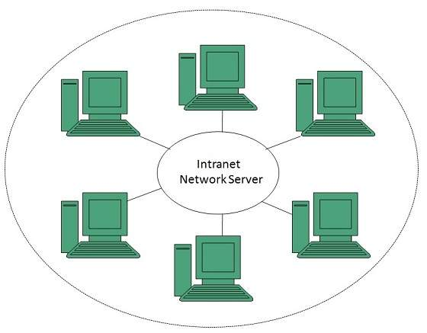

Figure 1: intranet architecture

* **HTML & CSS**

Hypertext Markup Language is a standard markup language for webpages. It acts as skeleton of webpage.

CSS stands for Cascading Style Sheets. It describes the presentation of a document written in HTML and how HTML elements are to be displayed on screen.

* **TCP**

Transmission Control Protocol is a standard communication protocol which establishes a network communication to exchange data. Because it is connection-oriented, it ensures a connection is established and maintained until the exchange between the application/servers sending and receiving the message is complete. CP takes messages from an application/server and divides them into packets, which can then be forwarded by the devices in the network: switches, routers, security gateways to the destination.

# Methodology

The first thing for development of any product is to understand to requirements. To develop this system, we need to find out what the restaurants and customers want in system. Depending on type of need, we have proposed that this system can be developed based on incremental model. Since our team is not highly skilled, the system is easier to debug and flexible and we need early versions to check the functionality, incremental development model is the best choice.

## Software development lifecycle

Incremental Model is a combination of linear sequential model (waterfall model) and iterative prototype model. In this model, requirements are divided into multiple independent modules. Each module goes through the requirements, design, implementation and testing phases. Every subsequent release of the module adds function to the previous release. The process continues until the complete system is achieved.

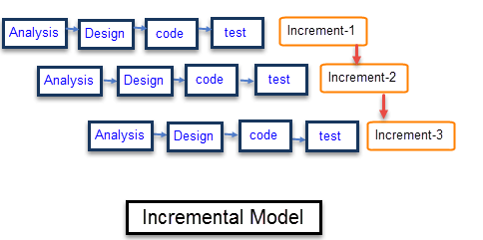

Figure 2: incremental model

* **Analysis phase**

In this phase, all requirements like functional requirement, hardware and software requirement, etc. are found out and their feasibility is determined. The cost and time for project is estimated.

* **Software requirements**

Web browsers: Mozilla Firefox, Opera, Chrome

Operating system: Windows, Mac, Linux

Backend: Php

Database: MySQL

Front end: HTML, CSS, Ajax

1. **Hardware requirements**

Any PCs with 2.5ghz processor, 2GB Ram, and 128Gb hard disk can act as server for this system. Other hardware includes routers for internet access.

1. **Functional requirements**

Admins: database access, update menus, add or delete items in database

Customer: select table and order items from menu, view bill and ordered items

Kitchen: receive orders, notify food is ready.

A use case diagram is the primary form of system/software requirements for a new software program underdeveloped. Use cases specify the expected behavior (what), and not the exact method of making it happen (how). It shows interaction between use case and actors.

The use case diagram for this system is

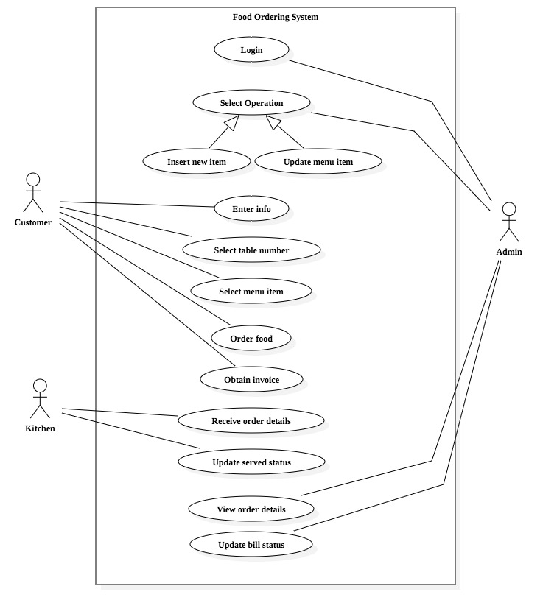

Figure 3: use case diagram

* **Design**

In this phase, system layout is developed. Use case diagrams, ER diagrams, et c are developed to understand the working mechanism of system.

1. **Schema diagram**

Schema is the organisation and structure of a database. A database schema can be represented in a visual diagram, which shows the database objects and their relationship with each other.

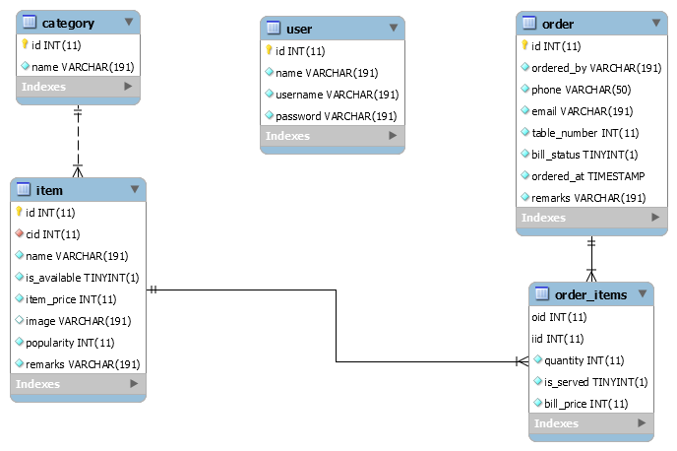

Figure : schema diagram

1. **Flowchart**

A flowchart is a diagrammatic representation of an algorithm, a step-by-step approach to solving a task.

There are two flowcharts in our project:

**Flowchart for admin**

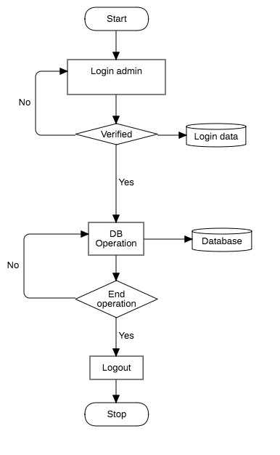

Figure : flowchart for admin panel

**Flowchart for customer**

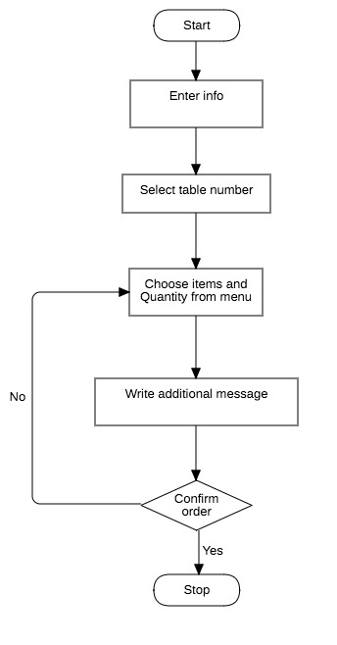

Figure : flow chart for customer side

1. **Sequence diagram**

A sequence diagram simply depicts interaction between objects in a sequential order i.e. the order in which these interactions take place.

The sequence diagram for making order by user in food ordering application is

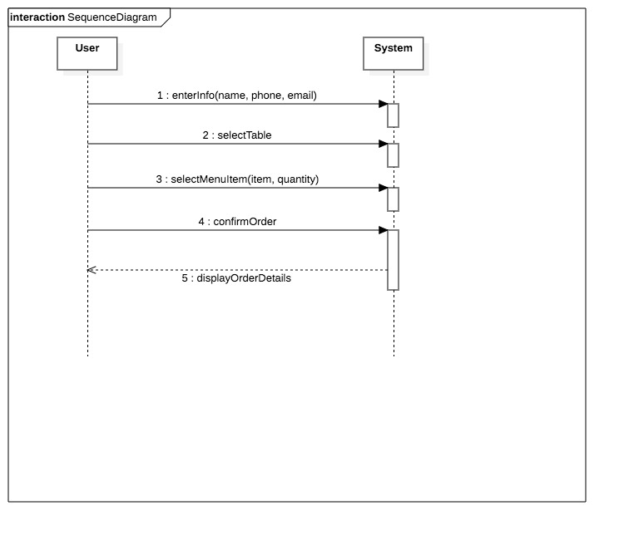

Figure : sequence diagram for ordering item

* **Coding phase**

The design is implemented in codes. The front end development is done using tools like HTML, CSS, bootstrap, etc. whereas the server side operations is done using Php and SQL queries.

* **Testing phase**

In this phase, the testing of each module is done. With addition of functionalities, system becomes more complex. The unit testing is done regularly until all modules are developed. Finally, integrated testing is done and then system testing is done.

Unit testing for admin panel

|  |  |  |  |  |  |
| --- | --- | --- | --- | --- | --- |
| Test case | description | input | Expected  output | Actual  output | remarks |
| T1 | Check Admin login | Id:admin  Password:admin | Log in to system. | Login to system | Test success. |
| T2 | Insert item operation | Input valid data | Add item to menu | item added to menu. | Test success. |

Table : test cases for admin panel

Unit testing for customer

|  |  |  |  |  |  |
| --- | --- | --- | --- | --- | --- |
| Test case | description | input | Expected output | Actual output | Remarks |
| T1 | Check login information | Name: a  Phone: 98  Email: aa | Invalid email | Email doesn’t include @ | Test success |
| T2 | Order summary | Select items from menu and put order | Order summary with items and price | Order summary with items and price | Test success |

Table : unit test cases for customer

**Admin login test t1: incorrect password**

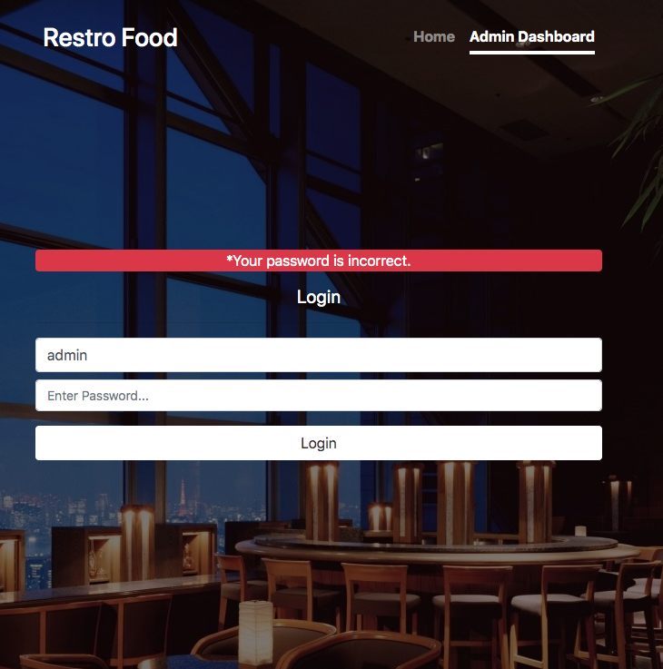**admin login test T1: unregistered username**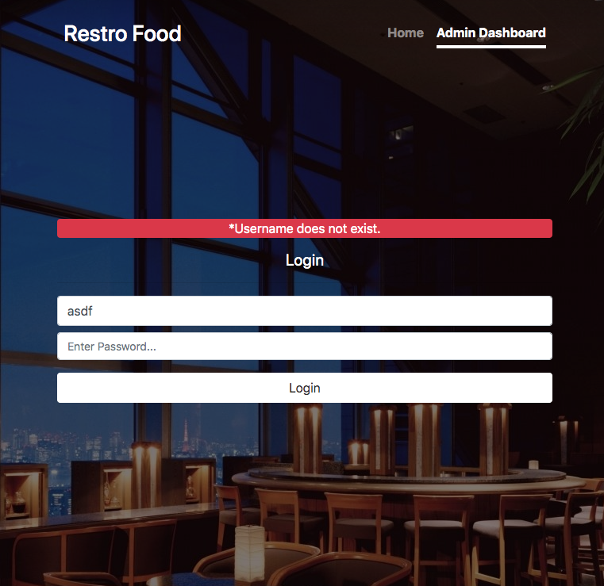

**Customer login test T1** 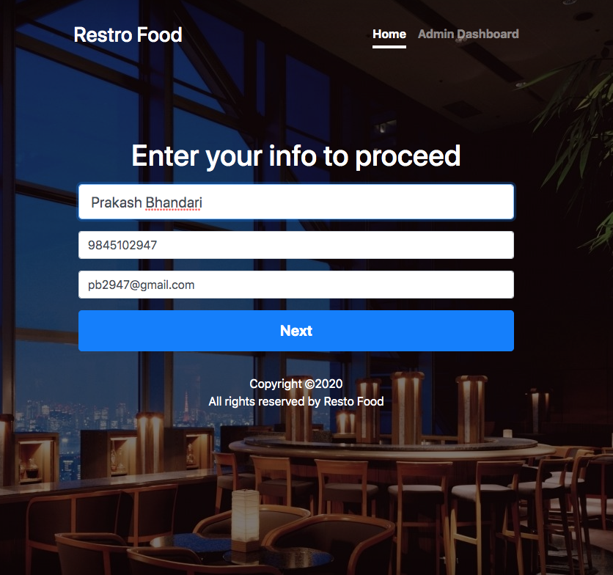

## Tools used

|  |  |
| --- | --- |
| **tools** | **purpose** |
| JavaScript | Front end programming |
| Php | Server side programming |
| MySQL | Database management system |
| phpStorm | IDE |

Table : tools used in project

# Conclusion

This project was performed with the objective of creating a better food ordering process eliminating the need of paper menus. This system is developed using interactive programming language for friendly user experience and with all necessary features and security need for transactions. It is accessible and affordable to all kinds of user and can be customized to meet specific demands.

Various test cases have been carried out to check whether the system functions properly or not. All test results show positive sign and the system can handle large number of concurrent order requests.

This system is ready to use in market and very useful considering few additional features are added. In the present scenario where no such digital menus are used, this project can be a pioneer to greater future projects.

# Further works

Considering the time limit of the project, this system can perform only basic features. With changing user need and consumer demands it can be refurnished to support advanced features.

Some further works that can be done in this project to make it more compatible and adaptable :

1. Adding user rating feature for each item on menu.
2. Integrating payment system with the application
3. Enhancing customer experience by suggesting customer based on previous interests.

# Bibliography

1. “Incremental Model” retrieved from:

<https://www.javatpoint.com/software-engineering-incremental-model>

1. “What is intranet” retrieved from

<https://www.tutorialspoint.com/internet_technologies/intranet_overview.htm>

1. <https://www.w3schools.com/>
2. S.Pressman “Software Engineering Fundamentals”, Seventh Edition
3. “use case diagram” retrieved from  
   [www.visual-paradigm.com](http://www.visual-paradigm.com)
4. <https://stackoverflow.com/>
5. <https://www.geeksforgeeks.org/>
6. “how to draw schema diagram” retrieved from

<https://www.edrawsoft.com/how-to-draw-database-model-diagram.html>

# Appendix

## Appendix I

This appendix list consists pseudo codes of various operations.

**Pseudo code for customer input**

**<?php  
if** (!**isset**($_POST['confirm_order'])) {  
 header('location: index.php');  
}  
**else** {  
 $full_name = $_POST['full_name'];  
 $phone = $_POST['phone'];  
 $email = $_POST['email'];  
 $table = $_POST['table'];  
 $remarks = $_POST['remarks'];  
  
 **include** 'connection.php';  
 $stmt_order = $conn->prepare("INSERT INTO `order` (ordered_by, phone, email, table_number, remarks) VALUES (?, ?, ?, ?, ?)");  
 $stmt_order->bind_param("sssis", $full_name, $phone, $email, $table, $remarks);  
 $stmt_order->execute();  
 $oid = $conn->insert_id;  
  
 $stmt_order_items = $conn->prepare("INSERT INTO `order_items` (oid, iid, quantity, bill_price) VALUES (?, ?, ?, ?)");  
 $stmt_order_items->bind_param("iiii", $oid, $iid, $quantity, $bill_price);  
  
 $order_items = (array)$_POST['order_item_count'];  
 **foreach** ($order_items **as** $i => $order_item) {  
 $quantity = $order_item;  
 $iid = $_POST['iid'][$i];  
 $bill_price = $_POST['item_price'][$i];  
 **if**($quantity) $stmt_order_items->execute();  
 }  
}  
**?>**

## Appendix II

This appendix list consists screenshots of application user interface.

**Customer login form**



**Table selection**

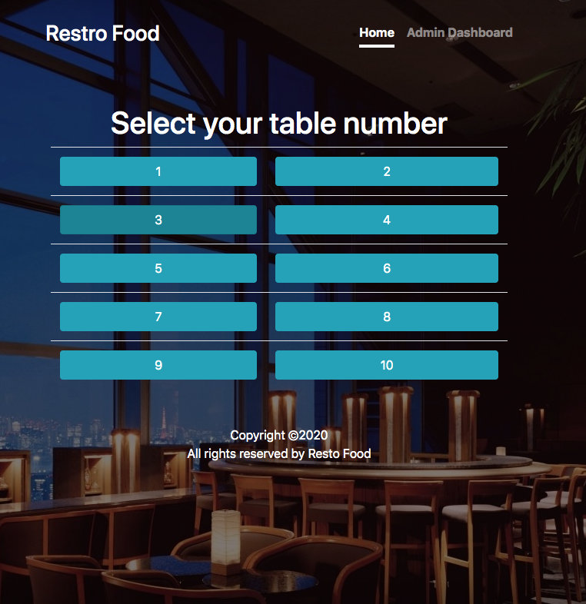

**Food item selection**

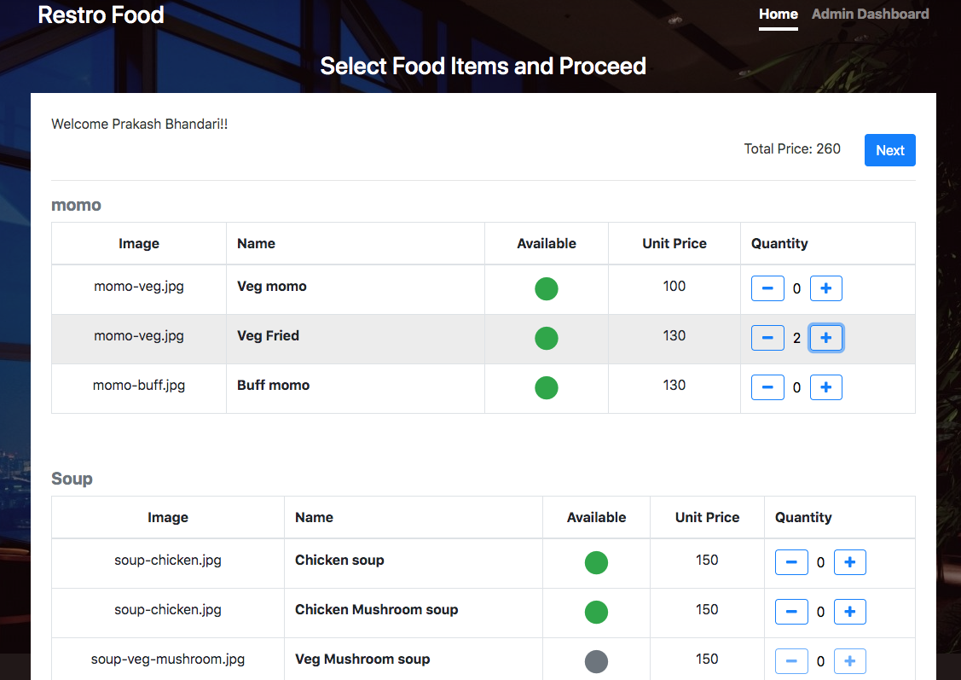

**Message from customer**

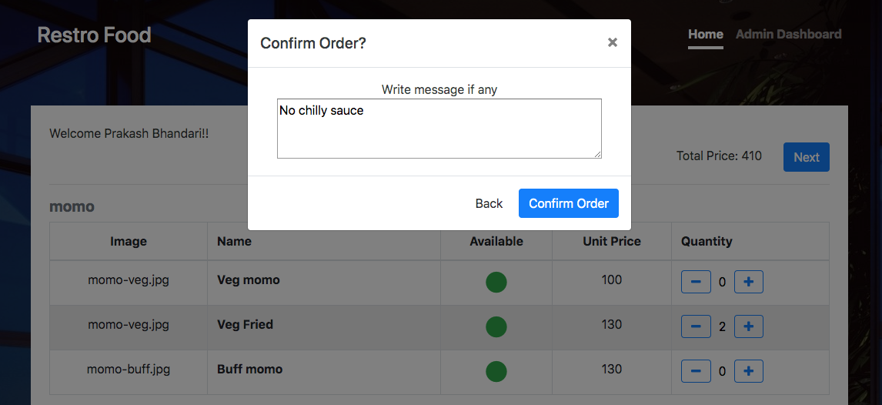

**Order details in admin panel**

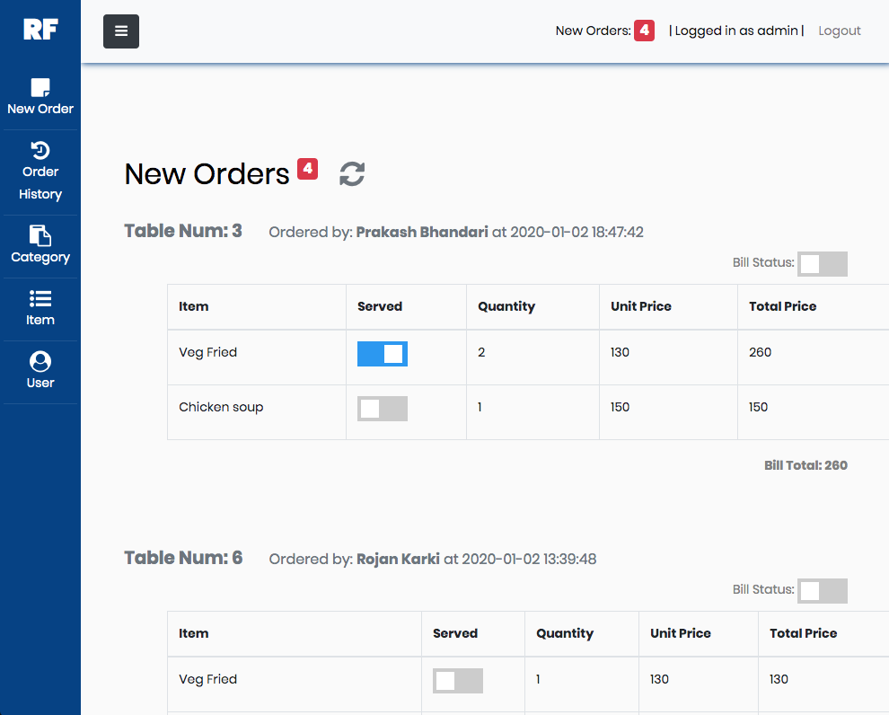

**Order history in admin panel**

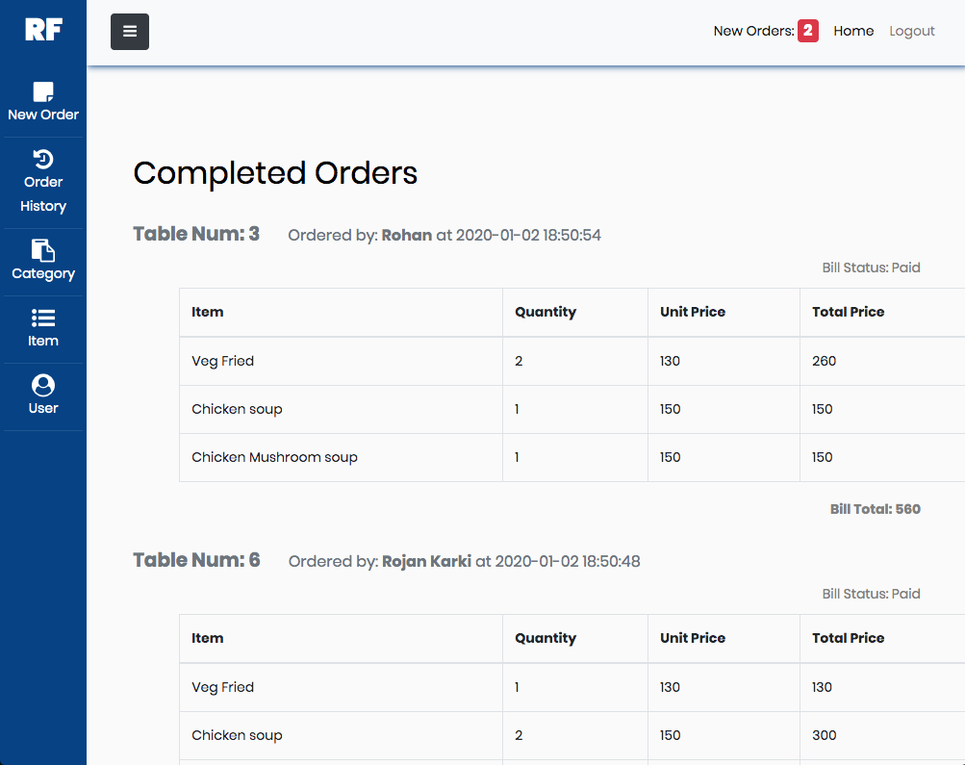

**Order summary in customer window**

